

MANGU 2025 KCSE PREDICTION
CONFIDENTIAL EXAM
312/2
GEOGRAPHY
PAPER 2
TIME: 2¾ HOURS

NAME……………………………………………………………………………………….
SCHOOL……………………………………………… SIGN………………………..
INDEX NO……………………………………………. ADM NO……………………

(Kenya Certificate of Secondary Education)

INSTRUCTIONS TO CANDIDATES
- This paper has two sections: A and B.
- Answer all the questions in section A.
- Answer question 6 and any other two questions from section B.
- All answers must be written in separate answer sheets provided.
- This paper consists of 5 printed pages.

FOR EXAMINERS USE
SECTION | QUESTION | CANDITATE SCORE
A | 1 - 5
B | 6
 | 7
 | 8
 | 9
 | 10
TOTAL

SECTION A
Answer all the questions in this section
1. The map below shows the Trans- Africa highway from Mombasa to Lagos. Use it to answer question (a)
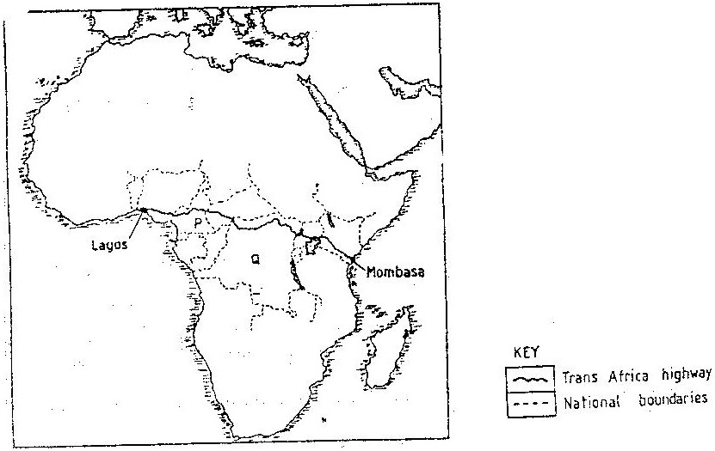
(a). Name the countries marked P and Q. (2mks)
(b) State three reasons why it is difficult to transport goods from Mombasa to Lagos along the highway (3mks)
2.a) Give three reasons why hardwood tree species in Kenya are in danger of extinction (3mks)

b) State two ways in which softwood forest in Kenya differ from those of Canada. (2mks)

3(a) A part from rural – rural migration, list three other types of migrations in Kenya. (3mks)
(b) Give two causes of rural – rural migration in Kenya (2mks)
4. (a) Name two rivers in Kenya which cause large scale flooding ( 2mks)
(b) State three methods through which floods can be controlled. (3mks)
5. (a) Name three types of beef cattle reared in Argentina. (3mks)
(b) Give two ports in Argentina through which processed beef is exported to overseas markets (2mks)

SECTION B
Answer question 6 and any other two questions from this section
6. The table below shows the quantity of minerals produced in Kenya in tonnes between years 2001 and 2005. Use it to answer questions (a) (i) and (ii).
Mineral/Year | 2001 | 2002 | 2003 | 2004 | 2005
Soda ash | 297,789 | 304, 110 | 352, 560 | 353, 835 | 360, 161
Fluorspar | 11,885 | 85,015 | 80, 201 | 117, 986 | 26, 595
Salt | 5,664 | 18,848 | 21,199 | 31,139 | 26,595
Others  TOTALS | 6,093  321,431 | 7,000  414,973 | 4,971  458,931 | 6,315  509,275 | 8,972  422,323
(a) (i) Calculate the average annual production of soda ash over the 5 years period. (2mks)
(ii) Using a scale of 1cm represent 100,000 tonnes, draw proportional circles representing total mineral production for years 2001, 2002, and 2004. Use diameter method. (7mks)
(b) State two uses of soda ash (2mks)
c) The diagram below shows shaft mining.
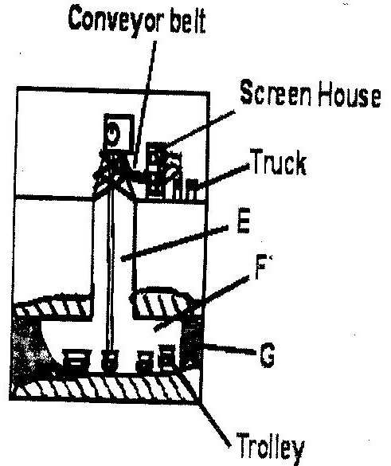
- Name the parts marked E, F and G. (3mks)
- State two problems associated with shaft mining. (2mks)
d (i State three negative effects of mining on the environment (3mks)
(ii) Explain three ways in which gold mining has contributed to the economy of South Africa. (6mks

7.a) i) Name two historical sites on the Kenyan coastal region that attracts tourists (2mks)
(ii) Explain the differences between the tourist attractions in East Africa and Switzerland under the following sub- headings
- Climate (2mks)
- Culture (2mks)
b) Explain four benefits that Kenya derives from tourism (8mks)
(c) Explain three measures that Kenya should take in order to attract more tourists (6mks
(d) Some students carried out a field study on inland tourist sites.
(i) Identify two sampling techniques the students may have used during the study. (2mks)
(ii) Give three advantages of sampling the area of study. (3mks)

8.(a) (i) State five problems experienced in irrigation farming in Kenya (5mks)
(ii) Explain three conditions that favour irrigation farming in Kenya (6mks)
(b) Describe the stages in the reclamation of land from the sea in the Netherlands (6mks)
(c) Explain four benefits of land reclamation in the Netherlands (8mks)

9. Study the map below and answer the questions that follow
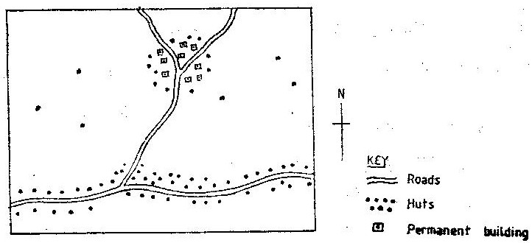
(a) Name the main settlement pattern in:
i) The northern part of the map. (1mk)
ii) The southern part of the map. (1mk)
b) State four factors that led to the development of Kisumu town (4mks)
c) List five functions of New York City (5mks)

d) Explain four problems facing urban centres in Kenya (8mks)
(e) You intend to carry out a field study in the nearby urban center
(i) State three reasons why you will conduct a pre-visit to the area of study (3mks)
(ii) Give three advantages of studying the nearby urban center through field work. (3mks)

10(a) (i) Define the term international trade (2mks)
ii) Name three major imports from Europe to Kenya (3mks)
b) State four factors that influence external trade in Kenya (4mks)
c) Explain four ways through which Kenya will benefit from the renewed East Africa Cooperation (8mks)
d) Explain four negative effects of international trade (8mks)

